Chapter 11, Problem 78.

Find the wattmeter reading of the circuit shown in Fig. 11.93 below.

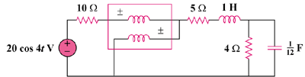

Figure 11.93
For Prob. 11.78.

